SUPPORT & RESISTANCE TRADE ANALYSIS REPORT
Chart Analysis

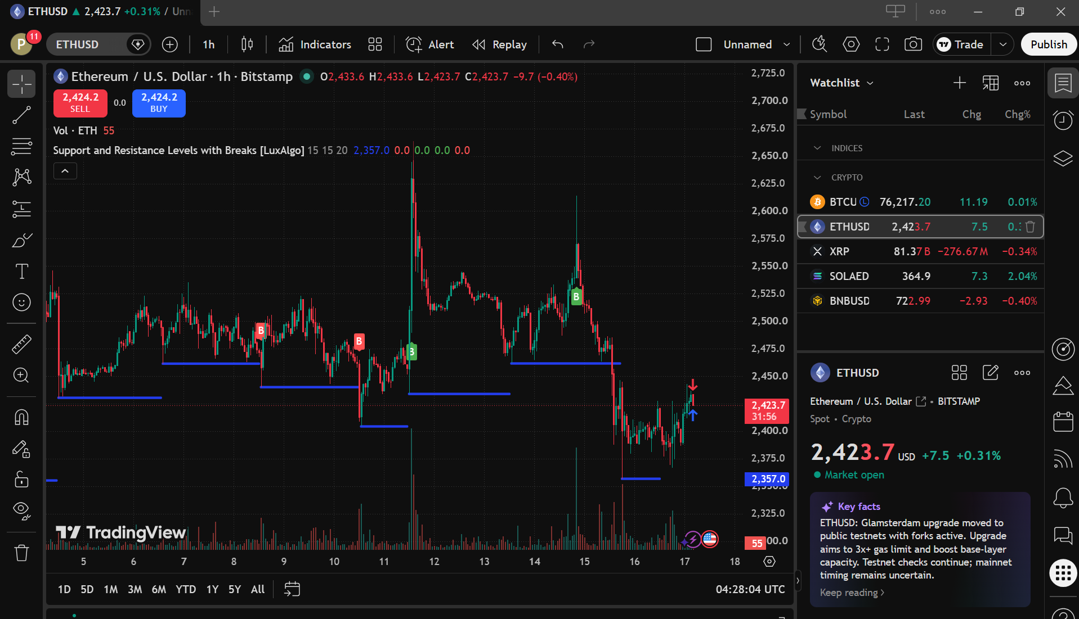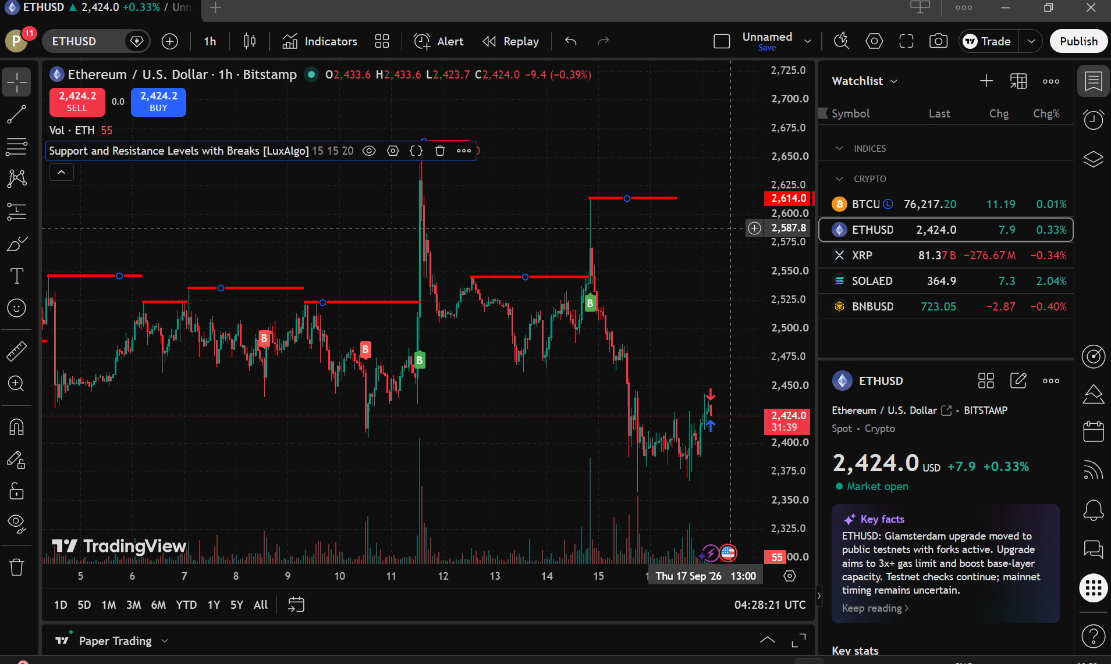

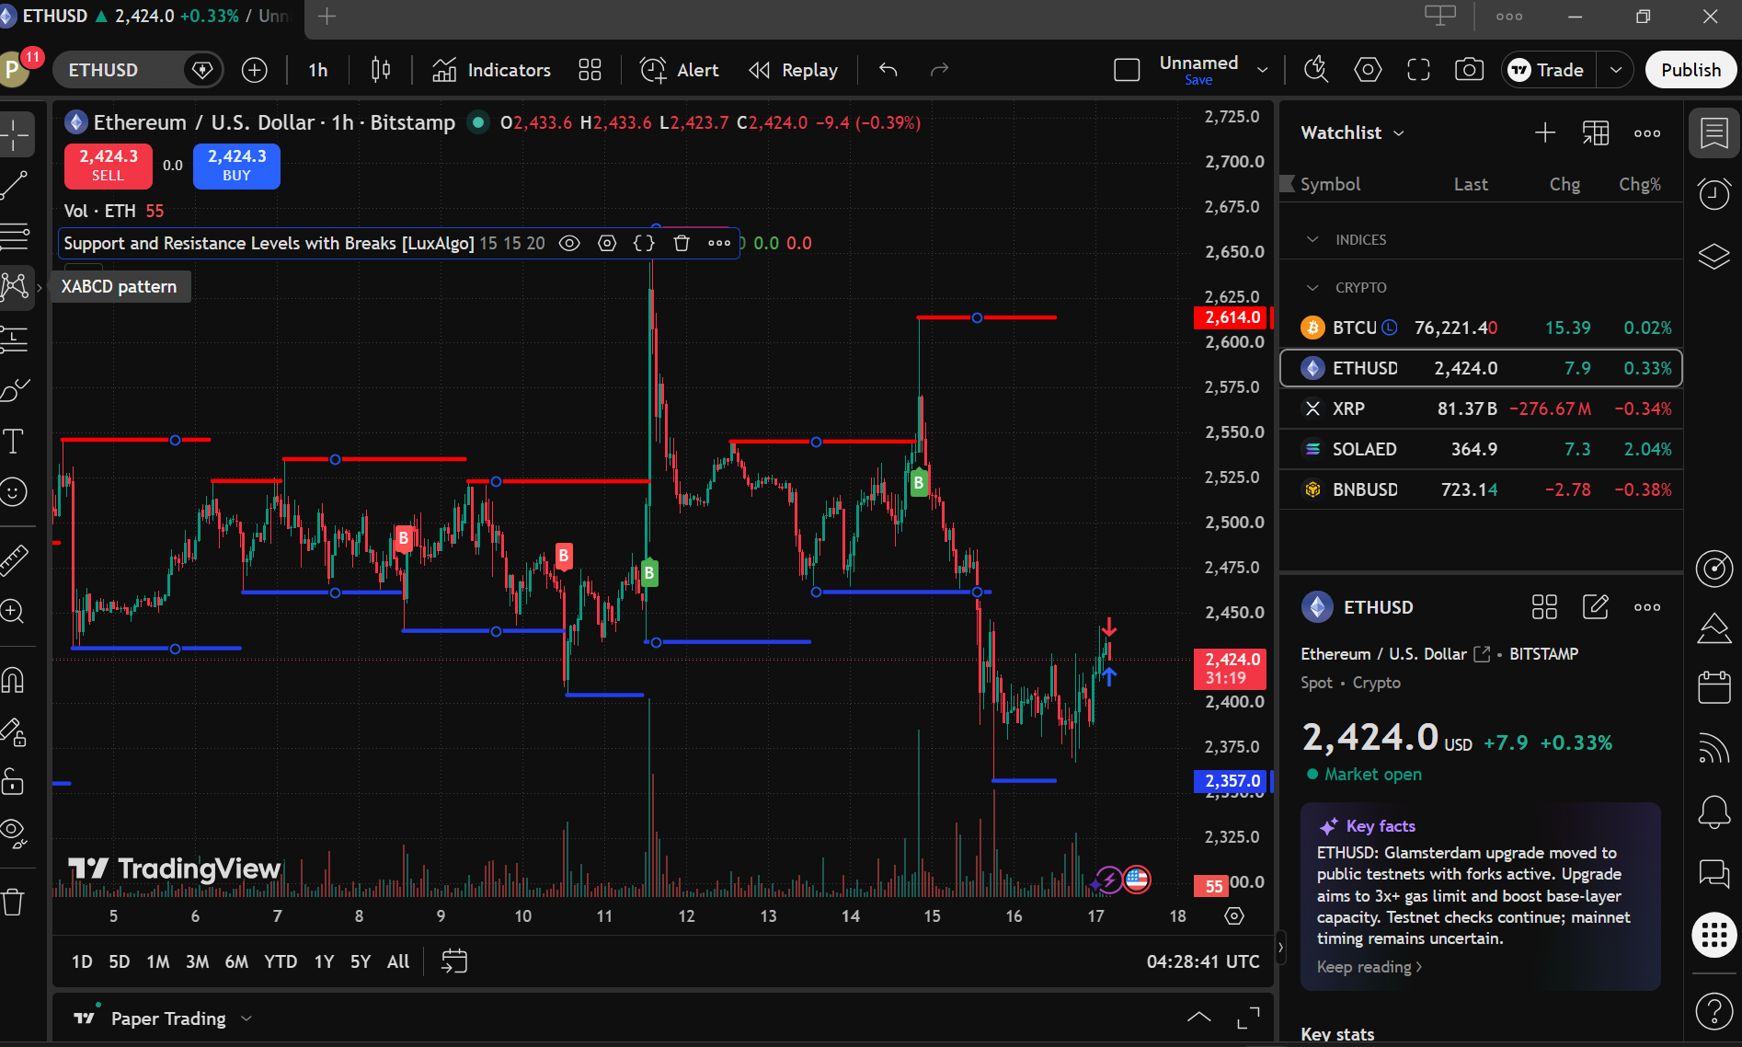
SUPPORT & RESISTANCE TRADE ANALYSIS REPORT
Chart Analysis
Particular | Observation
Asset Name
  Ethereum
Symbol | ETHUSD
Timeframe | 1 Hour (1H)
Support Level
  2,357 USD (Approx.)
Resistance Level
  2,614 USD (Approx.)
Current Price Position (Near Support /  Near Resistance / Between Levels) | Between Levels, closer to Support

Trading Decision
Particular | Observation
Trade Executed | yes
Trade Type (Long / Short / No Trade) | LONG
Reason for Trading Decision | The price is trading closer to the established support zone around 2,357 USD and has shown a short-term upward bounce from the recent low area. A LONG setup can therefore be considered if the rebound is confirmed by price action.

Trade Details

Particular | Observation
Entry Price
  2429.21
Exit Price | 2429.39
Realized Profit/Loss | +17.24
Trade Outcome (Profit / Loss) | PROFIT

